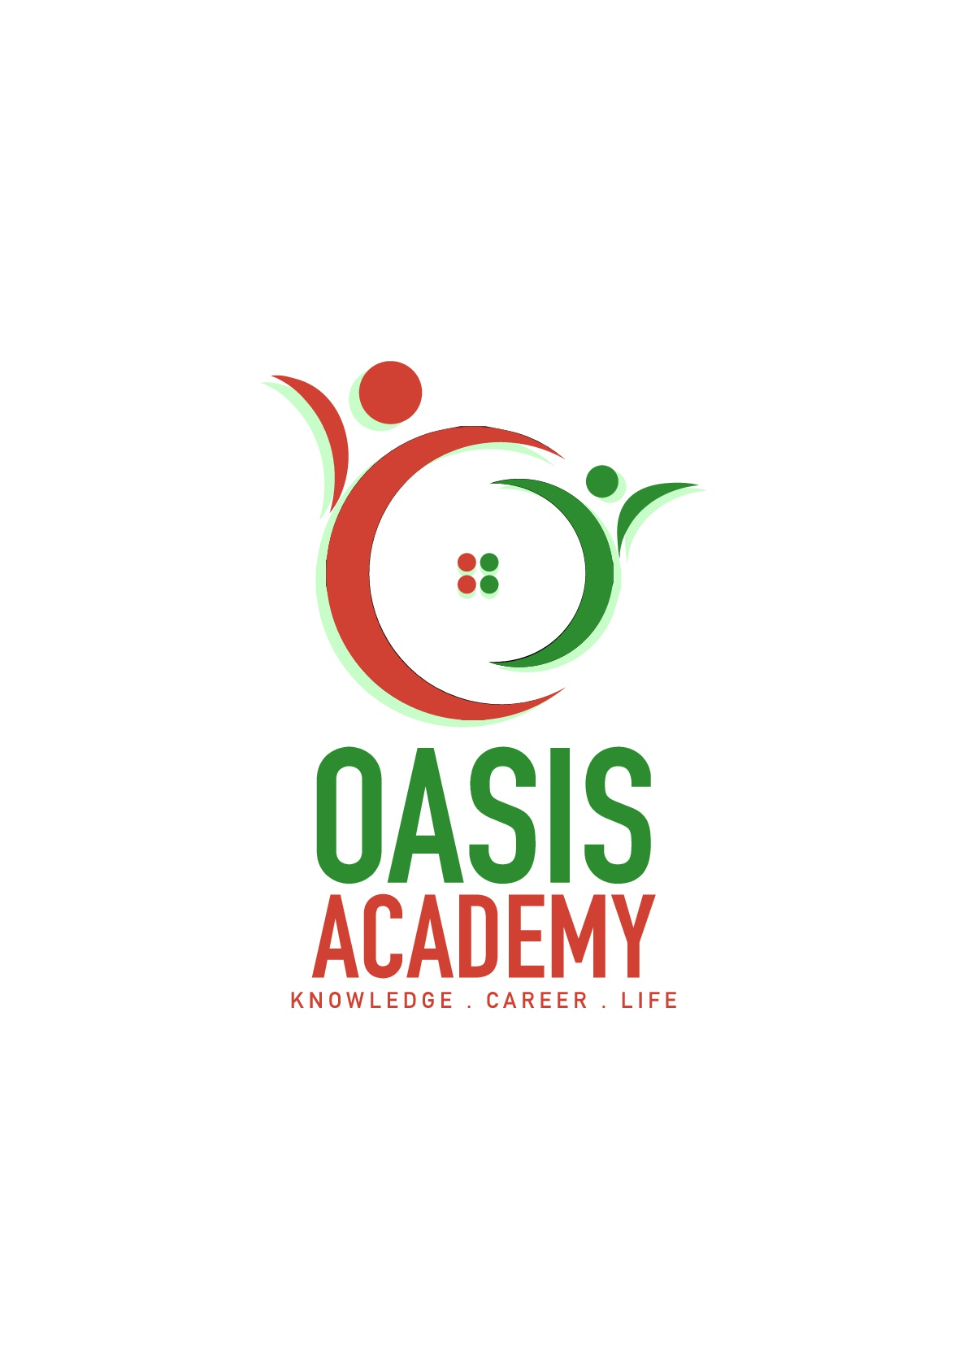

Name: Chee Fui Hlung

Login ID: [cheefui@oasis-portal.com](mailto:cheefui@oasis-portal.com)

Course title: Tourism and Hospitality

Subject Code: BHM03

Submitted date:

**Table of Contents**

|  |  |  |
| --- | --- | --- |
| **No** | **Details** | **Page** |
| 1 | Executive Summary | 3 |
| 2 | Introduction | 4 |
| 3 | Assignment Question |  |
|  | Question 1 | 5-7 |
|  | Question 2 | 8-10 |
|  | Question 3 | 11 |
|  | Question 4 | 12-13 |
| 4 | Conclusion | 14 |
| 5 | References | 15-16 |

**Executive Summary**

In this assignment I will be explain about the tourism and hospitality. In the first part, I will explain my understanding about the definition tourism and hospitality and also my understanding about hospitality industry. In the second part, I will also brief on a different type of the tourism categories. In the third part, I will describe my understanding about the lodging accommodation and types of hotel accommodation and also in the last part will explain in very detail about the significant of entertainment in this industry.

**Introduction**

what is tourism and hospitality ? it is an industry of provide customer service to people who want to travel. Professionals generally work in administrative or management position in service-based environment, and they are responsible for overseeing the operations and success of an establishment, such as a hotel or restaurant. The tourism and hospitality industry is diverse, and includes a lot of location including food establishments, boarding houses and youth hostels. While the overall goal of a hospitality professional is to ensure that guest and customer have pleasurable experiences.

**Assignment Question**

Question 1:

Define the Tourism and Hospitality

The matter of giving customer organization to travelers or untouchables. Friendliness specialists generally work in administrative or organization positions in an organization based condition, and they are responsible for regulating the operations and achievement of an establishment, for instance, a hotel or restaurant. The convenience and tourism industry is extraordinary, and fuses various regions including RV parks, sustenance establishments, recreational workplaces, campgrounds, lodgings and youth motels. While the general target of a convenience capable is to ensure that guests and customers have pleasurable experiences, they can in like manner be responsible for operations, for instance, utilizing and planning new staff; coordinating office and cash related association; housekeeping, upkeep, and security staff; and advancing.

Friendliness specialists moreover flow stores, set room rates, and certification that the organization models of the business are met. General commitments for friendliness specialists change dependent upon the traverse of the business and the measure of staff open. In greater operations, there is ordinarily a request of general executives, partner boss, and supervisors who work to perform operational assignments relating to their particular subjects. In a more diminutive business, the neighborliness capable plays out these assignments particularly.

As a less than dependable rule settlement capable positions are particular. For example, some consideration on managing the front office, while others can be accountable for custom organizations or cash related association. In case a settlement capable is used in a particular position, he or she ought to have incredible social capacities and the ability to work outstandingly near to associates in various zones of the business.

Supervisors slant toward hopefuls with a four year school training in business or hotel or cheerfulness organization, yet a human sciences degree nearby settlement experience may in like manner be commendable. Smaller establishments may recognize applicants with a presentation or accomplice's degree in cabin, invitingness or diner organization.

The cordiality business is impressively more broad than most extraordinary endeavors. The bigger piece of business claims to fame are made of just an unobtrusive pack out of different associations, however this industry applies to any association that is based on purchaser dependability and tending to lazy needs rather than principal ones. While this industry is to a great degree wide, there are some describing perspectives that are indispensable to get it Understanding Benevolence is divided into a few summary, for instance, portraying points, level of organizations, and moreover subjects.

Describing Viewpoints. A champion among the most portraying parts of this industry is that it focuses on shopper reliability. While this is substantial for practically every business, this industry depends totally on customers' being happy. This is in light of the fact that these associations rely upon giving luxury organizations. Not a lot of agreeableness associations give a crucial organization that people require, like support or dress. Another describing part of this industry is its reliance on optional capital and unwinding time. Hence, most of these associations are for voyagers or rich supporters. In case optional capital lessens due to a hang or withdraw, by then these are oftentimes the essential associations to persevere in light of the fact that customers won't have the extra money to benefit as much as possible from their organizations.

Different Associations. Most by far envision that hotels alone have a place with the kind disposition business, yet lodgings are just a single piece of this industry. Many sorts of transportation that oblige explorers are in like manner part of this business world. For example, this claim to fame consolidates flying machines, travel dispatches and significantly fancier trains. Diners, general tourism and event orchestrating furthermore have a place with this claim to fame. Some of these associations midway have a place with the warmth business. For example, a fast food restaurant would be seen as favorable. A restaurant that outfits support sustenance with staggering organization would be giving a warmth advantage.

Level of Organization. In spite of the business, this industry depends strongly on giving a splendid level of organization. Customers are passing by the business to make tracks in an inverse bearing from their burdens. A repulsive undertaking may shield them from returning until the finish of time. Brand steadfastness is basic to these customers, so the related associations do their best to give the best organization. Associations secure workers in view of fitness and lead. The dominant part of these agents are unprecedented with customers, and they can consummately give the customer what he or she needs.

Subjects. Another describing some portion of the benevolence business is its point. This doesn't have any noteworthy bearing to every business in this industry, however a significant part of them use a particular subject to pull in customers. For example, some help restaurant may have a Mediterranean subject to pull in customers who like that sort of food and atmosphere.

Not solely does this different the business from contenders, be that as it may it additionally enables customers to judge the business on another level. Cheerfulness associations that give a real point are frequently reviving more than general settlement associations. If the above diner cooks sound Mediterranean nourishment and uses the right enhancing parts, by then this will make customers happy and moreover anxious to visit the business. A neighborliness business needn't waste time with a subject, yet most by a long shot of them use one since customers love themed associations.

Question 2 -

Brief on different type of Tourism categories.

Any usage of tourism and visitor related terms needs to see that tourism is, for the most part, a particular thought measured by the available bits of knowledge of visitor advancements and utilization and appraisals of the amount of a broad assortment of visitor workplaces. As a thought, tourism is unavoidably open to different interpretations anyway it is by and by extensively agreed that there is a desperate need to settle or achieve more unmistakable precision in the way that key tourism terms are used comprehensively, regionally and locally. Orchestrating and directing tourism when the distinctive accomplices included have assorted beginnings of what tourism means can just ever be not entirely productive.

Tourism is the non particular term to cover both demand and supply that has been gotten in various structures and used all through the World. Tourism is portrayed as the activities of individuals recognized as guests. A visitor is some individual who is making a visit to a crucial objective outside his/her standard condition for not as much as a year for any essential reason [including] events, unwinding and stimulation, business, prosperity, preparing or diverse purposes… .This augmentation is impressively more broad than the standard perspective of tourists, which included only those going for amusement

Visitor is the common factor that covers each one of the sorts of tourism described above for a comparative extent of purposes. The term handles three separate characterizations. Vacationers who are visitors staying away from home for no less than one nighttimes for any of the reasons noted above (family unit, or from abroad). Same Day visitors, generally called voyager day visitors spending no under 3 hours from home outside their common condition for general unwinding, recreational and social purposes. Many are neighborhood inhabitants of an area. Unwinding day visitors spending under 3 hours from home however outside their average condition, for general entertainment, recreational or social purposes. Not joined these short stay unwinding day visitors contribute direct to the area visitor economy and should similarly be formally seen in objective organization decisions. By far most of this third assembling of visitors are also occupants of objectives and their neighborhood catchment zones.

The term 'tourism endeavors' is the all around recognized UNWTO/OECD importance of twelve standard mechanical game plans of the parts of the economy that give organizations ate up by visitors. The turnover in view of tourism in each of these fragments is measured by diagrams of visitor utilization, is from the demand side, by and large in the private part however including some open territory organizations. Yet accommodating and in like way usage by specialists, the media and government authorities, there is no recognized worldwide or national importance of the term 'tourism industry.'

A term now for the most part used all through the UK, in spite of the way that not yet formally described, visitor economy insinuates general demand and supply in each one of the sections inside which visitor development and its quick and circuitous results upon the economy happen. The term visitor economy is more broad than the significance of tourism ventures, which it joins, and it incorporates all staying and non-staying visitors. The term gets a handle on the activities and utilization connected with giving things and organizations to visitors by both the private and open sections. It moreover consolidates the mainly open part practices and liberal utilization on the creation, support and headway of individuals when all is said in done space and the system inside which, and through which, visitor practices happen. Visitor economy can be used as a piece of association with worldwide, national and sub-national land objectives or zones and need not by any means be confined by existing chronicled limits. 'Tourism undertakings' are, in like manner, a sub-set of the visitor economy.

Visitor objectives are places that are seen as visitor objectives and for which it is possible to gage parts of the enthusiasm for and supply of tourism benefits inside described points of confinement. Visitor objective is gotten a kick out of the chance to 'tourism objective' in light of the fact that by definition it joins all arrangements of visitor. Typically such objectives have some sort of open/private portion affiliation set up; they are lifted as spots to visit and have some kind of organization process set up for visitor related purposes. At adjacent level, objective points of confinement in the UK are by and large yet not by and large coterminous with no less than one neighborhood specialists or alloted parts of such legitimate domains, for example, National Parks. At regional level objective points of confinement will reliably be a mix of close-by master association territories. At national level the breaking points are those of the country. These levels consider EU assentions zone association. The UNWTO fundamentally describes the essential objective of a tourism visit as "the place passed by that is key to the decision to take the trip."

But extensively used all through the UK, Objective Organization is a modestly later and vaguely used thought as yet amid the time spent setting up a formal definition. It is an agreed various leveled process for driving, influencing and sorting out organization of the key parts of an objective that add to a visitor's experience having regard similarly for the necessities of adjacent tenants, associations and the earth. Fruitful organization requires estimation and masterminding and headway frames for the visitor economy of an objective as a noteworthy part of general adjacent expert plans. Though private zone consideration is principal, effective objective organization moreover requires the dynamic speculation of neighborhood masters and vital open division bodies. Visitor economy related affiliations are ordinarily suggested as Objective Organization Affiliations or DMOs. While the organization viewpoints are fundamental to enhance the potential preferences in the visitor economy, most DMOs have for the most part been encircled as publicizing affiliations and some may not long for, or pick not to, consolidate the organization segments noted already. Everything considered these bodies are logically suggested as Objective Affiliations.

Open area is a recognized and for the most part used term in the UK for spaces generally uninhibitedly available for use by the all inclusive community. Related with ordinarily used terms, for instance, put shaping, put making or remarkableness of place, open space consolidates the costs and organization of organizations that relate to the progression and utilization of spaces, for example, town and downtown regions, stops and plants and beautiful provincial reaches and most well known structures. Such spaces are essentially the quick obligation of close-by specialists sponsored by Government, neighborhood business rates, council forces alone wage obtaining works out. A couple of parts of open space game plan are oftentimes in like manner for the most part vested in other open territory associations working with neighborhood authorities. In conjunction with the all inclusive community area and close-by master masterminding, the private fragment in like manner has and keeps up a huge part of the structures and land enveloping open spaces and once in a while the home through which free is given. In the more broad setting, open area is constantly part of the area individual fulfillment for occupants it describes the uncommonness and interest of spots, and effects inward wander all around.

Question 3 -

Describe the lodging accommodation and types of Hotel accommodation.

The hotel offers a basic part in trading associations, gatherings and recreational workplaces in numerous countries. In various locales, the hotel is a basic interest for guests to attract clients, and they are more prepared to consume through money than at home. The hotel business is depicted by sumptuous motels from excess resorts and campgrounds. Comfort is an absolutely wide branch of the hotel business, including bed to breakfast business and motel to other settlement workplaces. Customer advantage is essential for settlement organizations. This is not all, viability, comfort, and faultless workplaces are also the commence. An excess resort should give customers security and prohibitive organizations to cut it in the strength. They are the three essential sorts of lodgings and offices, which is Settlement, Suite, and Resort. Settlement is when people take off beginning with one place then onto the following, they require a place to rest, a refuge that shields them from the masses of nature. This incited a booking lodge and accommodation. Suite is despite the general stay, the motel in like manner offers extraordinary suites. When in doubt, suites are fitting for formal enrollment, which is exorbitant diverged from general room advantage. Resort is the second rate class of settlement that is common among voyagers is a resort. These impact you to close nature and give you a fundamental rest from your formal calendars. The going with are a bit of the gathering of settlement; the hotel gives voyagers paid comfort and distinctive organizations for the guests. Dependent upon the size, region and workplaces, the hotel is generally from one star to five stars yet also explored and other rating plans are in like manner used to portray lodgings around the world. Boutique hotel typically completed in a theme independent style, the degree of the boutique motel private, focused on giving guests astounding tweaked association. Timeshare is an escape property with shared ownership and use rights. Furthermore, the choice of time-sharing rental can be an ideal choice for staying in hotel rooms, giving quality workplaces and better regard. Climbers Motel is a cabin for spending voyagers, generally attracting young customers. The room is home system the restroom is shared, despite the way that there may be a private room. Despite house costs, you can moreover give light meals. A self-giving sustenance establishment may be fundamentally one of the other comfort sorts, yet what's more offers an excellent buffet office. The unit should be outfitted with a totally arranged kitchen to meet the best number such as tallying coolers, stoves, cutlery, ceramic, cookware, cleaning equipment. The kitchen should be first class to the guests, not the offer.

Question 4 -

Explain the Significant of Entertainment in this industry.

Entertainment, paying little heed to whether for business or enjoyment, are an essential bit of our lifestyle. Offices, incitement, sustenance and drink and travel and tourism are basic portions of the varying neighborliness industry. In every way that really matters each portion of this market area relies on fabricated establishment, a lot of which may have necessities that are unique to the settlement business. Chat has worked successfully finished the scope of the neighborliness and preoccupation markets to address troubles in siting, layout and improvement. A key piece of the tourism business is attractions which offers visitors a chance to examine the sights, workplaces and wonders of their objectives. Attractions all around fuse prominent sits, heritage homes, show corridors, entryways of reputation, craftsmanship shows, proficient flowerbeds, ski inclines, aquariums, zoos, water parks, redirection park,casinos and social attractions. There redirection and media outlet fuses bundle practices that range from fowl review and salmon calculating to horseback riding, whitewater sculling, hitting the fairway, wild trekking and enlightening visits to drawing in shots. Notwithstanding measure, these scenes expect people to work in gift shops and restaurants, and what's more enable keep up the workplaces, to manage the operations and propel the attractions.

Craftsmanship display corridors assemble true and current perfect works of art for informational purposes and to spare them for who and what is to come. Open presentations, on the other hand, don't generally assemble or screen artful culminations. Or, on the other hand possibly, they focus on introductions of contemporary acts and on tasks of addresses, conveyances, and distinctive events. The term authentic focus covers a broad assortment of establishments from wax displays to sports passageways of acclaim. Regardless of what sort of presentation corridor it is, many are directly inquisitive concerning whether historical centers are as yet applicable in the present forefront world. As needs be, display corridors are using new development to develop the visitor experience. One delineation is the Lofty BC Authentic focus, which has a web Learning Passageway, records late related tweets on its point of arrival, and is home to an IMAX theater playing IMAX movies that relate to the display appears.

A natural plant is a garden that grandstands neighborhood and non-nearby plants and trees. It conducts enlightening, research, and open information programs that enhance open perception and valuation for plants, trees, and gardening.Canadian proficient flowerbeds have a normal 4.5 million visitors for every year and are basic science and educational workplaces, giving specialist in plant safeguarding and state financed preparing .

While social and inheritance attractions attempt to show information in perspective of outstanding and creating social orders and realities, occasion assemblies are attractions that much of the time work to make substitute, eccentric substances. Entertainment meccas have a long history backpedaling to the 1500s in Europe, and have created starting now and into the foreseeable future. Today, it is hard not to endeavor to differentiate any occasion gathering objective with Disneyland and Disney World. Opened in 1955 in brilliant California, Disneyland set the standard for amusement parks. The Pacific National Introduction (PNE) in Vancouver is seen as one of BC's most obvious diversion meccas and starting late lauded its 100-year remembrance (PNE, 2015).

The Widespread Word reference of Event Organization portrays a festival as an open celebration that passes on, through a kaleidoscope of activities, certain ramifications to individuals and onlookers. Different definitions, including those used by the Ontario Trillium Foundation and the European Union, highlight receptiveness to the general populace and brief traverse as key parts that describe a festival.The wide nature of festivities has incite the progression of portrayal sorts. For event, financing for the government's Building Society through Articulations and Heritage Program is available under three classes, dependent upon the sort of festivities. Neighborhood festivities sponsoring is given to adjacent social events to rehashing festivities that present made by neighborhood authorities, craftsmans, or recorded performers. Gathering remembrances financing is given to adjacent social affairs to non-rehashing neighborhood events and capital ventures that recollect a recognition of 100 years. Legacy financing is given to aggregate capital assignments that commend a 100th celebration of a basic neighborhood recorded event or close-by irrefutable character.

**Conclusion**

In my opinions, hospitality standardmust be mmaintained at an all the time high to ensure the quality.

**Reference**

https://www.beyond.com/tourism/defined

http://www.besthospitalitydegrees.com/faq/what-exactly-is-the-hospitality-industry/

https://www.merriam-webster.com/dictionary/tourism

http://www.tourismsociety.org/page/88/tourism-definitions.htm

http://yourbusiness.azcentral.com/three-categories-hospitality-industry-24003.html

http://www.tc.gov.yk.ca/tourism.html

https://opentextbc.ca/introtourism/chapter/chapter-1-history-and-overview/

https://www.hotwire.com/helpcenter/hotels/searching-and-booking/locations-properties-reservations/what-different-lodging-types.jsp

http://www.luxuryaccommodationsblog.com/post/114961446726/different-types-accommodation-tourism

https://www.wisdomjobs.com/e-university/hotel-front-office-management-tutorial-369/types-of-lodging-facilities-12982.html

http://www.google.com/url?sa=t&rct=j&q=&esrc=s&source=web&cd=1&cad=rja&uact=8&ved=0ahUKEwiqxIeJz6fWAhXMKo8KHY5yBRAQFggoMAA&url=http%3A%2F%2Fwww.edb.gov.hk%2Fattachment%2Fen%2Fcurriculum-development%2Fkla%2Fpshe%2Fnss-curriculum%2Ftourism-and-hospitality-studies%2FHospitality_English_21_June.pdf&usg=AFQjCNElCcH2q13vleZEOG1KNATGFjeJpQ

http://www.besthospitalitydegrees.com/faq/what-exactly-is-the-hospitality-industry/

https://www.visitbritain.org/introduction-tourism

The End